NEWSLETTER

May 2022

Golden Hills Lodge: 403 443 5333
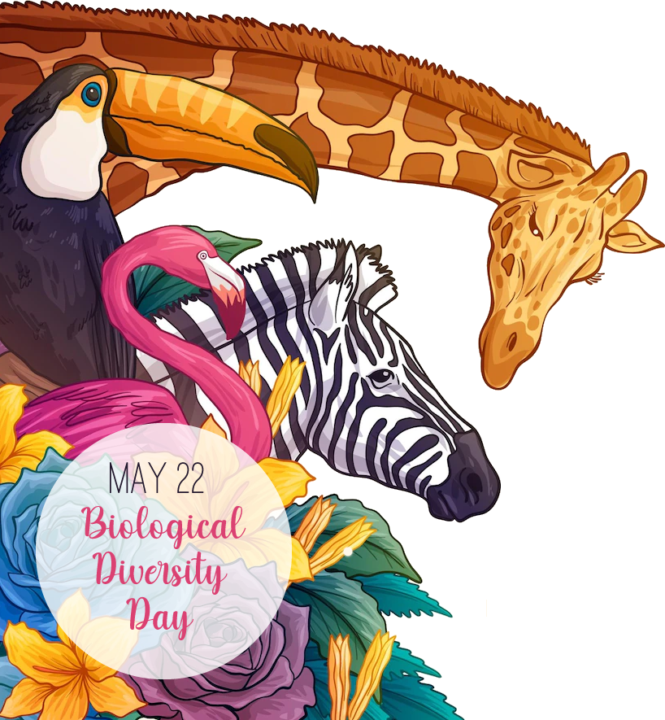 | IN THIS ISSUE  - Editor’s Desk ..……… 2  - Month in Review ……. 3  - Upcoming Events …….4  - May Birthdays ……. 5  - A Poem to Share .….. 6  - Noticeboard ……..….. 7  - Laughing Matters ……. 8  - Spotlight …………… 9  - Word Search ………… 10

Editor’s Desk
Hello Residents, Families and Friends!
This last month was challenging for everyone, but I want to thank you for being patient and understanding as things are constantly changing!
I’m excited to start activities up again and get back into shape with those morning exercises! I encourage you to come out and try something new this month!

Keep Safe!
Morgan
Quote of the Day
A person who never made a mistake never tried anything new.

– Albert Einstein
May Trivia

The Month of May. May is named for the Roman goddess Maia, who oversaw the growth of plants.

Zodiac signs: Taurus & Gemini
Birthstone: Emerald
Flower: Lily of the Valley
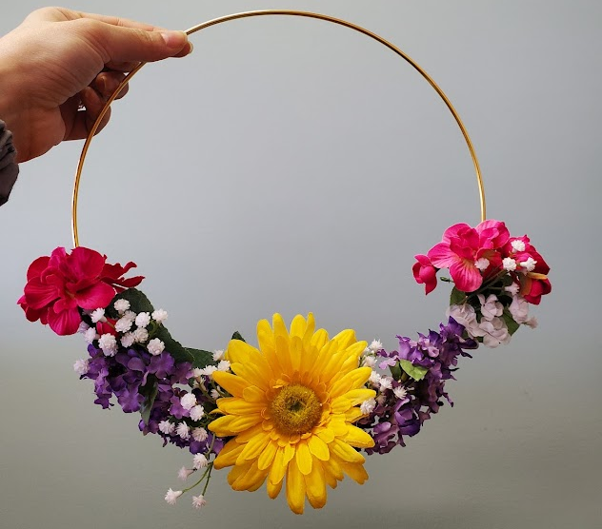
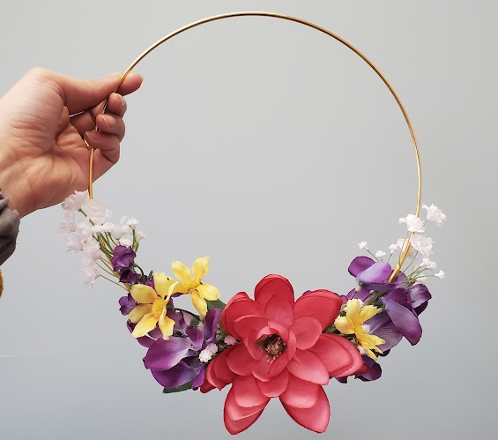

Month in Review
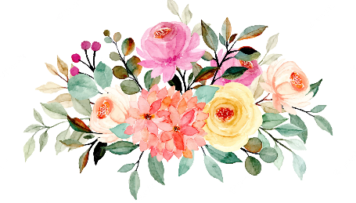
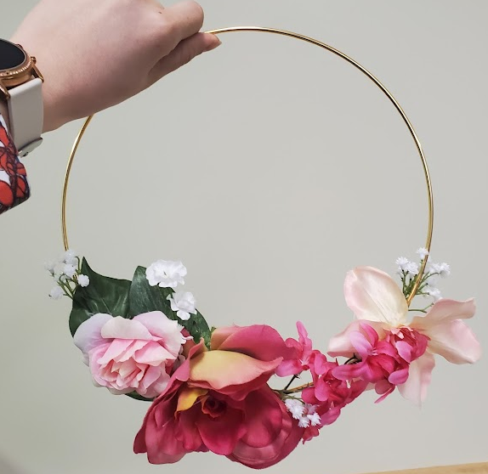
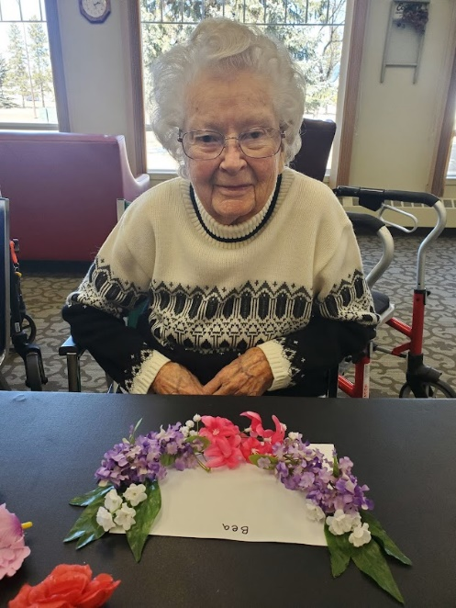
Upcycled Spring Wreaths

We got to create these beautiful spring wreaths by using the leftover flowers from our Spring Banquet in March. They sure do brighten up the hallways!

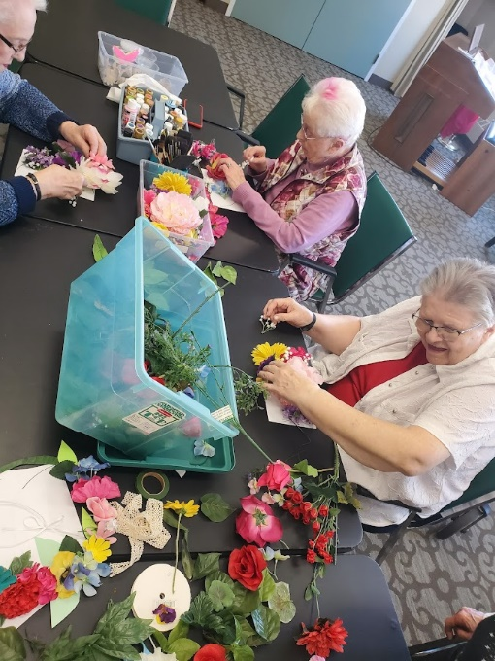
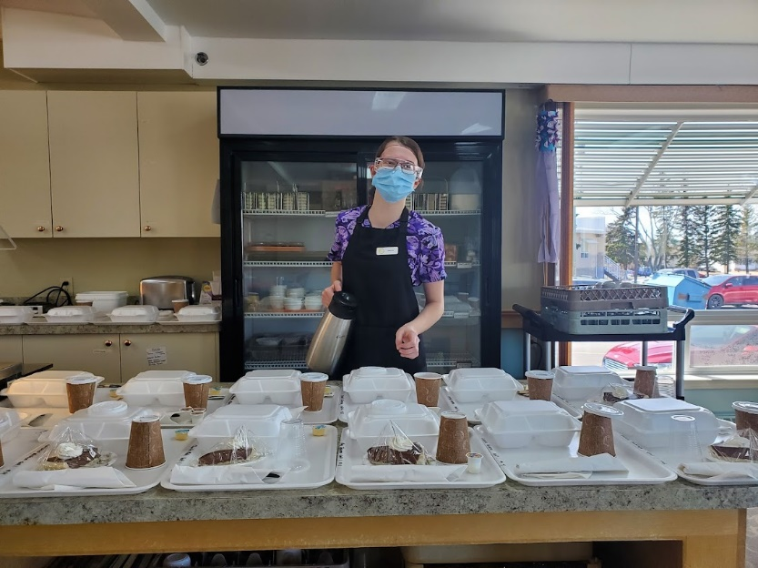
Thank you to GHL Staff

We had some amazing kitchen staff go above and beyond this last month.
Be sure to thank them for all they do!
Comment about photo

Mary Lou enjoying time in the garden. The weather has been beautiful and residents have been enjoying spending time outdoors.

Upcoming Events

Seniors Outreach Presentation
Thursday, May 5th at 10:00am
Mother’s Day Tea
Monday, May 9th at 2:00pm
Bus Trip out to the Country- Please sign up!
Monday, May 16th at 2:00pm
Special Days

4th Space Day
5th Cinco de Mayo
8th Mother’s Day
12th Intl. Nurses Day
14th Migratory Bird Day
22nd Biological Diversity Day
23rd World Turtle Day
28th Cannes Film Festival

30th Memorial Day

RCMP Fraud and Scam Awareness Presentation
Friday, May 13th at 2:00pm
Ice Cream Bar
Thursday, May 19th at 2:00pm
Armchair Travel to Italy
Tuesday, May 31st at 2:00pm

Regular Events
Reading with June Every Friday at 11am
Three Hills Ministerial Service Every Sunday at 4pm
Card Games in ¾ coffee room every morning at 10:30am
Library every 2nd Thursday at 10:30am-11:30am in the Bird Room
Listen to a Bible Study every Saturday at 10:00am
Watch Prairie Tab Church Service in Auditorium at 10:30am every Sunday

May Birthdays
In May, we celebrate 3 birthdays!

Please join us in the auditorium on Wednesday,
May 25th at 2:00pm to celebrate!

Taurus (Apr 20 – May 20)
Taureans are dependable, logical, and overall peaceful beings

Gemini (May 21 – Jun 21)
Geminis love to learn and they never stop wondering about the unexplained
Glenn Ford, Actor, 1st May 1916
Bing Crosby, Singer, 2nd May 1904
Lesley Gore, Singer, 2nd May 1946
Audrey Hepburn, Actress, 4th May 1929
Karl Marx, Philosopher, 5th May 1818
Sigmund Freud, Psychiatrist, 6th May 1856
Orson Welles, Actor, 6th May 1915
Stevie Wonder, Singer, 13th May 1950
Peggy Lee, Singer, 26th May 1920
Clint Eastwood, Actor, 31st May 1930
Product Birthday Spotlight: Barbie Doll
On May 9 1958, Mattel's Barbie doll was registered. The Barbie doll was invented in 1959 by Ruth Handler (co-founder of Mattel), whose own daughter was called Barbara.

Poem to Share

The Rose Family
Robert Frost

The rose is a rose,
And was always a rose.
But the theory now goes
That the apple's a rose,
And the pear is, and so's
The plum, I suppose.
The dear only knows
What will next prove a rose.
You, of course, are a rose -
But were always a rose.

Noticeboard

New Residents
A very warm welcome to:
- Joyce B
We hope that you enjoy your time here!
Three Hills Library Service
NOTICE OF CHANGE: Due to the lack of demand in recent months, the library will now ONLY be every 2nd Thursday of the month from 10:30-11:30 in the BIRD ROOM.
In Memoriam
To the families and friends of our late residents—may you be comforted by the knowledge that your loved ones are at peace.
- Abe Wiebe
- Barb Penner
- Irene Jacques
Lodge Library Lines
Thanks to all of you who are making use of the 'Book Return' boxes that are placed at both of our library shelves.
Also, a few residents have donated some of their own books to our library. If you have books you think other residents might like to read and want to donate them to our library, please contact Donna so she can place them in our 'New To Us' section of the library. Please don't put them in the Return Box as we won’t know if they are new.
Sorting and organizing the books is slowly progressing and suggestions are welcome.
Be happy, read a book!
Seniors outreach
We have a wonderful service available to us in this community. Terry Schlinker will join us on May 5th at 10:00am to share about the various services that are available for you!

Laughing Matters

The Pearly Gates
A woman died and found herself standing outside the Pearly Gates, being greeted by St. Peter.
She asked him, "Oh, is this place what I really think it is? It's so beautiful. Did I really make it to heaven?"
To which St. Peter replied, "Yes, my dear, these are the Gates to Heaven. But you must do one more thing before you can enter."
The woman was very excited and asked St. Peter what she must do to pass through the gates.
"Spell a word," St. Peter replied.
"What word?" she asked.
"Any word," answered St. Peter. "It's your choice."
The woman promptly replied, "Then the word I will spell is love. L-o-v-e."
St. Peter congratulated her on her good fortune to have made it to Heaven and asked her if she would mind taking his place at the gates for a few minutes while he took a break.
"I'd be honored," she said, "but what should I do if someone comes while you are gone?"
St. Peter reassured her and instructed the woman simply have any newcomers to the Pearly Gates to spell a word as she had done.
So the woman is left sitting in St. Peter's chair and watching the beautiful angels soaring around her, when low and behold, a man approaches the gates, and she realizes it is her husband.
"What happened?" she cried, "Why are you here?"
Her husband stared at her for a moment, then said, "I was so upset when I left your funeral, I was in an accident. And now I am here? Did I really make it to Heaven?"
To which the woman replied, "Not yet. You must spell a word first."
"What word?" he asked.
The woman responded, "Czechoslovakia''
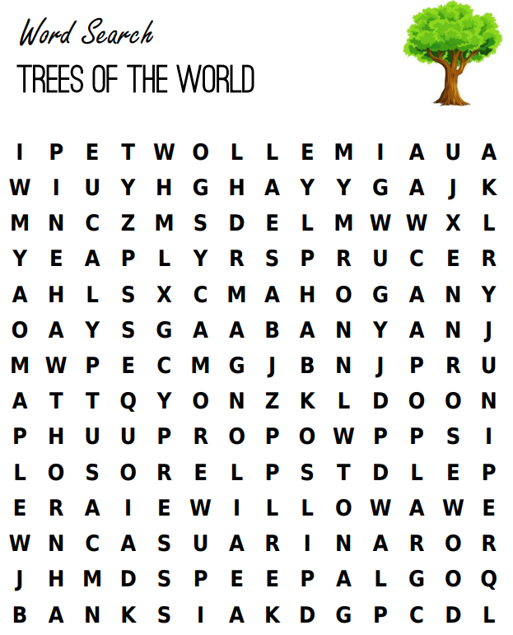

Banyan Cypress Hawthorn Poplar
Mahogany Wollemi Sycamore Magnolia
Maple Rosewood Sequoia Eucalyptus
Elm Pine Banksia Spruce
Juniper Willow Peepal Casuarina

