NEWSLETTER

April 2023

IN THIS ISSUE

  - Editor’s Desk ..………… 2
  - Month in Review ………. 3
  - Upcoming Events …….. 5
  - April Birthdays ……… 6
  - A Poem to Share .…….. 7
  - Noticeboard ……………. 8
Monthly Poster Board……. 9

  - Laughing Matters …….. 11
  - Staff Spotlight/Name that Resident ………………… 12
  - Crossword…………… 13

Editor’s Desk
Hello Residents, Families and Friends!
A big Hello to the Month of APRIL! The days are getting longer and the drip of the melting snow is music to my ears! Soon we will be outside enjoying the sunshine and flowers, and yes even the Bee’s!
This month we are looking forward to a few big events. To start, we have invited an entertainment group in for a Dinner Theater experience here in the Lodge. Thursday April 14th we will enjoy our regular supper time meal and then move on to the Auditorium to enjoy an evening of entertainment with Richard and Deborah Popovich. We would love for you to invite family members if they are interested! If you know your family members would like to attend please sign up on the bulletin board with the number of guests who plan to attend as we need to ensure the auditorium does not breech it’s maximum capacity. Its going to be a wonderful show!
April 17-21st is Volunteer Appreciation Week and we have a few events planned to honor both our in-house resident volunteers, along with our regular community volunteers. Please make sure you read the bulletin board to see the details for that week’s celebrations. Also, if you are an in-house resident volunteer please look for an invite for a special outing to celebrate you and to say thank you for your help!
Our Garden committee will be meeting this month to meet our new Garden Volunteer and long-time Green Thumb, Shirley Arnold. We are so excited to have her join us here! She is going to be a great asset in navigating the duties of the 2023 summer Garden and flower beds!
We will also be meeting and forming a 2023 summer Parade committee this month. Any resident who is interested in helping to dream and plan with staff the Parade float and theme please see the events page of the newsletter and calendar for the date of our first committee. All help is welcome! We would love to have everyone help!
This month is going to be a great one! Be sure to read the bulletin boards for upcoming events and I will see you all around!
Keep Safe!
Brianne Rothfus – Activities/Volunteer Coordinator
Price is Right – Grade 9 PCA Boys

We had a great time with the PCA grade 9 boys at the beginning of the month! They came to visit and we had a lively game of The Price is Right!

March Madness

Walker Slingshot

Some Residents participated in a new activity, turning our walkers into slingshots! It was a great way to exercise our upper body muscles while have fun!
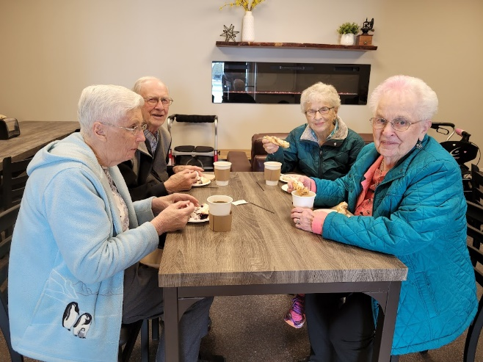
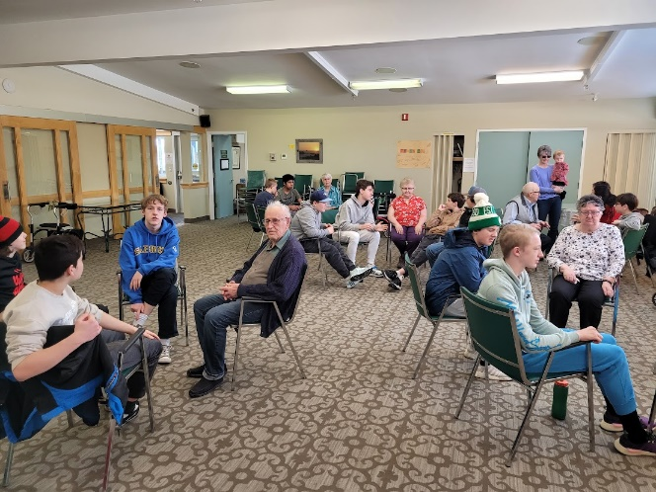
Busy Bee Coffee Shop and Bus Trip

We had a wonderful outing to the local Busy Bee Coffee shop this month! We were the first guests to try their new table and chairs in their new expanded dining area. We even had a last minuet stop at the Solar Panel Farm north of Town! Definitely a repeat outing!
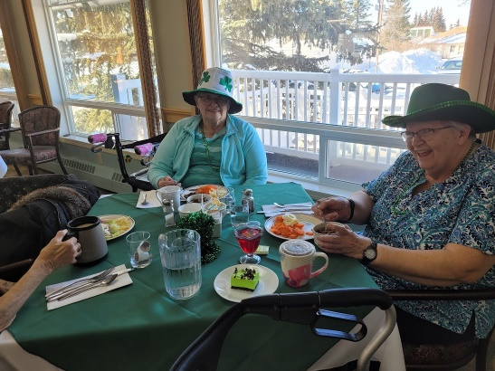
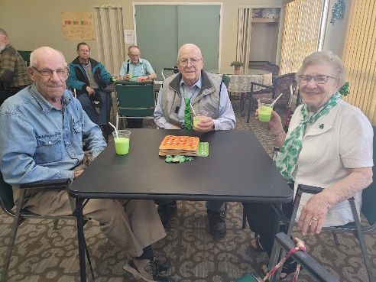
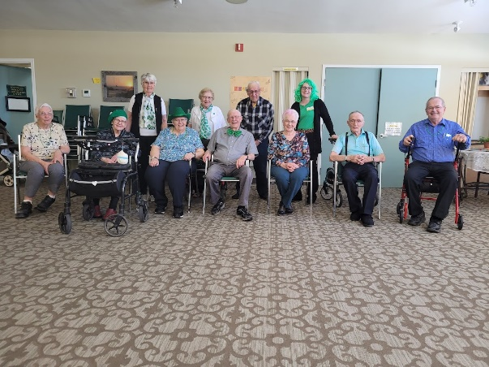
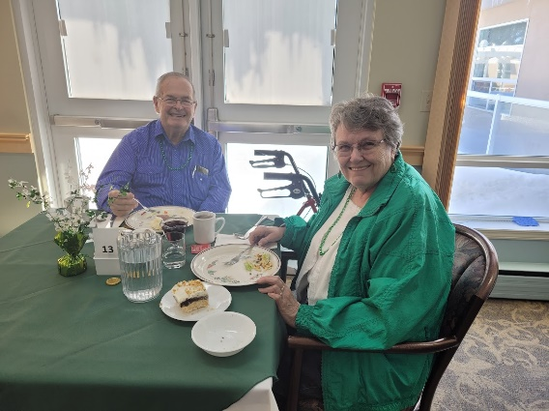
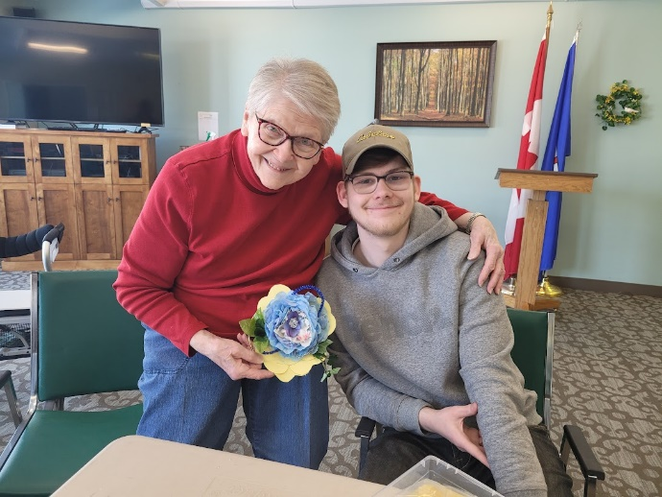
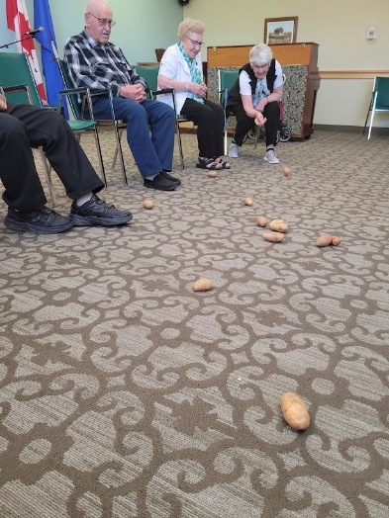
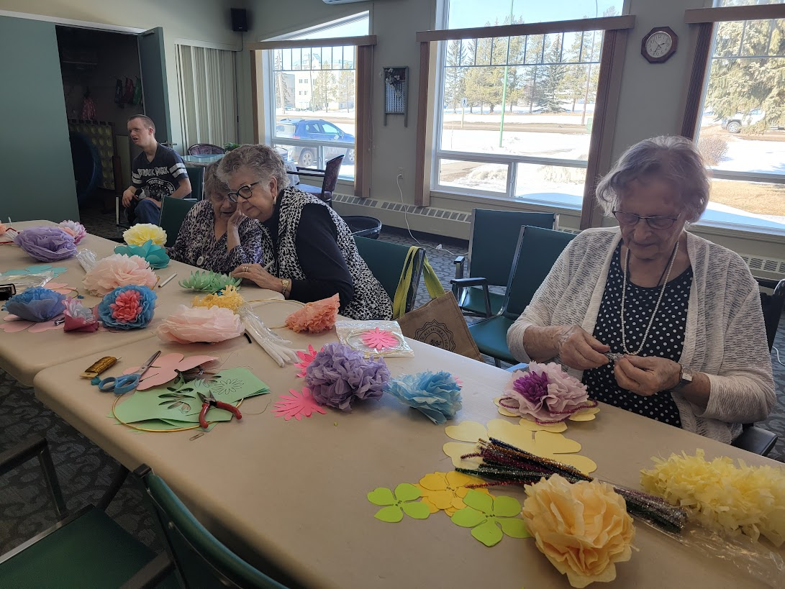
We had St. Patty’s Day BINGO and Shamrock Shakes!

Mary Lou enjoying time in the garden. The weather has been beautiful and residents have been enjoying spending time outdoors.
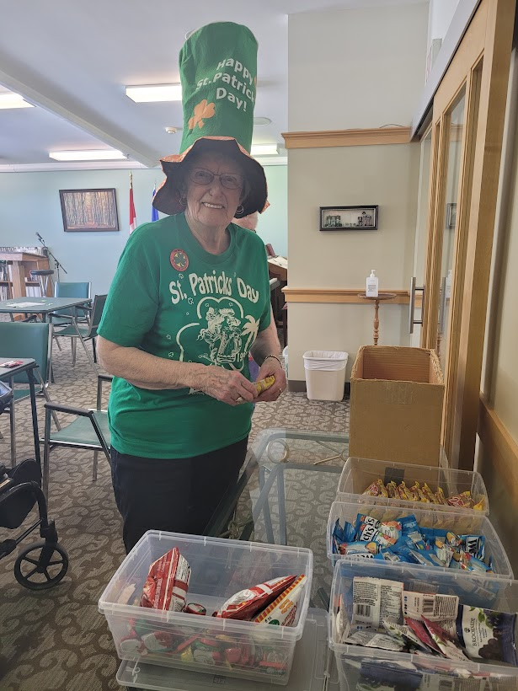
So many great outfits!

Mary Lou enjoying time in the garden. The weather has been beautiful and residents have been enjoying spending time outdoors.
Corned beef, Cabbage and Grasshopper Pie!

Mary Lou enjoying time in the garden. The weather has been beautiful and residents have been enjoying spending time outdoors.
Potato Bowling on St. Patty’s Day

Mary Lou enjoying time in the garden. The weather has been beautiful and residents have been enjoying spending time outdoors.
Mickey Nott and her Grandson, Isaac

Mary Lou enjoying time in the garden. The weather has been beautiful and residents have been enjoying spending time outdoors.
Walkers in Bloom – First day of Spring!

Mary Lou enjoying time in the garden. The weather has been beautiful and residents have been enjoying spending time outdoors.

Other March Events

Upcoming Events

Puppy Visit
Monday April 3rd at 10:30am, Auditorium
Ruth Poulsen’s Piano Recital and Students Monday April 3rd at 7:00pm, Auditorium. Refreshments to follow.
Men’s/Ladies Coffee Break
Tuesday April 4th at 10:00am, Men – Unit 5 Dining room, Ladies – ¾ coffee room
Regular Events
IDA Tuck Shop: Tuesday April 11th 10:30-11:30
Campfire Sing-along
Wednesday April 12th @ 2:00pm
Nimble Fingers
Thursday April 13th 9:00-10:00am
ATB Financial
Thursday April 20th @ 9:00am
Walking Group
Tuesdays @ 11am
Armchair Travel: To Israel with Rev. Brent Schulze
Tuesday April 25th at 2:00pm

FCSS Tax Clinic : Call to book appointment - 403 443 3800 Tuesday April 4th 1:00-4:00pm, Auditorium
Vitamin B12 Clinic
Wednesday April 5th 10:00am , Auditorium
Parade Planning Committee Wednesday April 5th @ 1pm – resident volunteers needed.
Daycare Easter Egg Hunt
Wednesday April 5th at 2:30pm, Auditorium and around the Lodge.
Garden Meeting
Tuesday April 11th at 1:00pm, Auditorium
Sunnyslope Mennonite Singers
Wednesday April 12th at 7:00pm
Popovich Dinner Theater Event Thursday April 13th at 6:30pm, Auditorium. Please feel free to invite family and friends!
Committee Meetings:

Garden Committee: Tuesday April 11th @ 1pm with Shirley Arnold and Brianne

Parade Committee and Planning: Wednesday April 5th @ 1pm
Summer Parade is Saturday July 8th
Resident Volunteers and Input Needed!
Resident Volunteer Appreciation Bus Trip Tuesday April 18th at 1:30pm: Harvest House
Community Volunteer Appreciation Luncheon Friday April 21st at 11:50 am

April Birthdays

In April, we celebrate birthdays with:
- Doris Wiebe
- Jan Magnusson
- Claire Roberts
- Richard Harsch
- Susie Stahl
Please join us in the Auditorium on April 19th at 2:00pm to celebrate!

Those with Birthdays this month, please feel free to invite your family members to our Birthday tea! We would love to celebrate with them!

Aries (Mar 21 – Apr 20)
Aries are passionate, motivated and confident leaders. They are bundles of energy & enthusiasm.

Taurus (Apr 21 – May 20)
Taurus are practical and well-grounded. They surround themselves with love & beauty.
Marlon Brando, Actor, 3rd April 1924
Eddie Murphy, Actor, 3rd April 1961
Russell Crowe, Actor, 7th April 1964
Jackie Chan, Martial Artist, 7th April 1954
Emma Thompson, Actress, 15th April 1959
Queen Elizabeth II, 21st April 1926
Jack Nicholson, Actor, 22nd April 1937
Barbra Streisand, Singer, 24th April 1942
Al Pacino, Actor, 25th April 1940
Michelle Pfeiffer, Actress, 29th April 1958
April 4, 1968: Martin Luther King is fatally shot
Civil Rights leader Rev. Dr. Martin Luther King was killed by a sniper in Memphis, Tennessee.
He had championed non-violent resistance to end racial oppression and had been awarded the Nobel Peace Prize in 1964. He is best remembered for his I Have a Dream speech delivered at the 1963 Civil Rights March on Washington.

Poem to Share

Song of Hope
by Thomas Hardy

O sweet To-morrow! –
After to-day
There will away
This sense of sorrow.
Then let us borrow
Hope, for a gleaming
Soon will be streaming,
Dimmed by no gray –
No gray!

While the winds wing us
Sighs from The Gone,
Nearer to dawn
Minute-beats bring us;
When there will sing us
Larks of a glory
Waiting our story
Further anon –
Anon …

.
New Volunteers
- Olita Lowen: Cards/Games 2x month
- Alia Pasman: Monday Morning Games
- Nathan Ramer: Tuesdays 2X month 3:45pm-4:30pm
- Shirley Arnold: Garden Volunteer
- Elli Burak – Fridays and Special Occasions
- Naleah Klassen – Fridays and Special Occasions
New Staff
A warm welcome to our new Maintenance Staff starting in April!
- Chris
We hope that you enjoy your time here!

Noticeboard

Hairdresser
We continue to look for a regular hairdresser for our Lodge. Thank you for your patience in this matter.
In the meantime, we have Kerstin stepping in as Hairdresser every Wednesday. A sign-up sheet and price list is posted on the salon door. Anyone wishing to use her services please sign up!

Garden plots and flowers
Anyone wishing to have a garden plot for the summer 2023 year who does not already have a plot assigned, please see Brianne for information.
Anyone is welcome to bring and purchase their own flower pots for around the lodge. Please know, you are responsible for the upkeep, watering and seasonal cleanup at the end of the summer season.

THANK YOU
We would like to issue a heartfelt thanks to all our Resident Volunteers who help with our specific tasks around the Lodge every month: Minnie Cummings, Clarence Creasser, Judy Canfield, Donna Dubois, Orlene Csakany, Margaret Nielsen, and all involved with our Garden and Parade Committee! I thank you all very much!

Noticeboard

Monthly Poster Board

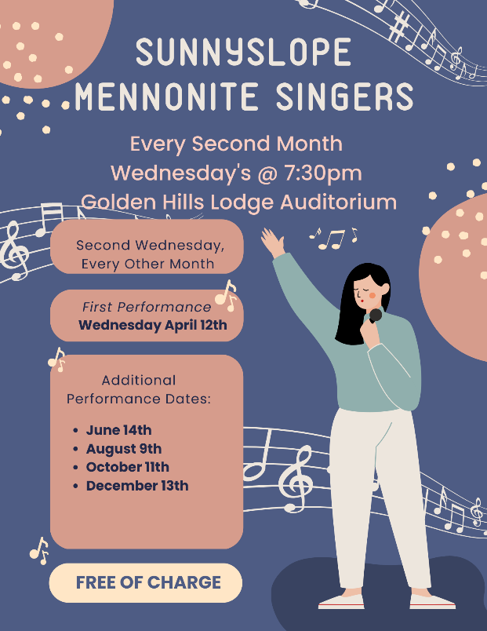

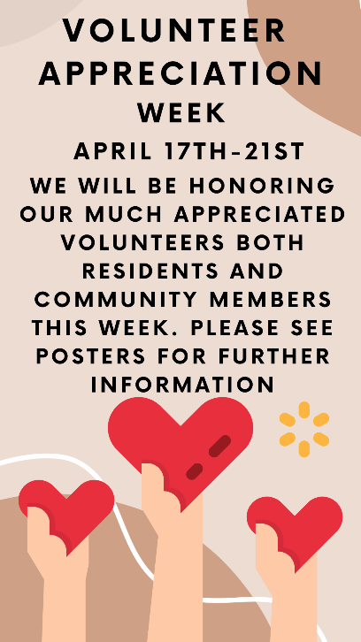
All Posters can be seen around the building in the four main areas:
Outside Jim’s office,
Unit 2A
Unit 5
And Outside the Auditorium.

Laughing Matters

The Hunters
Two hunters are out in the woods when one of them collapses.
He doesn’t seem to be breathing and his eyes are glazed.
The other guy whips out his phone and calls the emergency services.
He gasps, “My friend is dead! What can I do?”
The operator says “Calm down. I can help. First, let’s make sure he’s dead.”
There is a silence, then a gunshot is heard.
Back on the phone, the guy says “OK, now what?”

Late Payment
A customer sent an order to a distributor for a large amount of goods totaling a great deal of money.
The distributor noticed that the previous bill hadn’t been paid. The collections manager left a voice-mail for them saying, “We can’t ship your new order until you pay for the last one.”
The next day the collections manager received a collect phone call, “Please cancel the order. We can’t wait that long.”

Short Jokes
Why did the tomato turn red?
Because it saw the salad dressing!
Two guys stole a calendar.
They got six months each.
Why did the old man fall in the well?
Because he couldn't see that well.
Did you hear about the restaurant called Karma?
There's no menu - you get what you deserve.
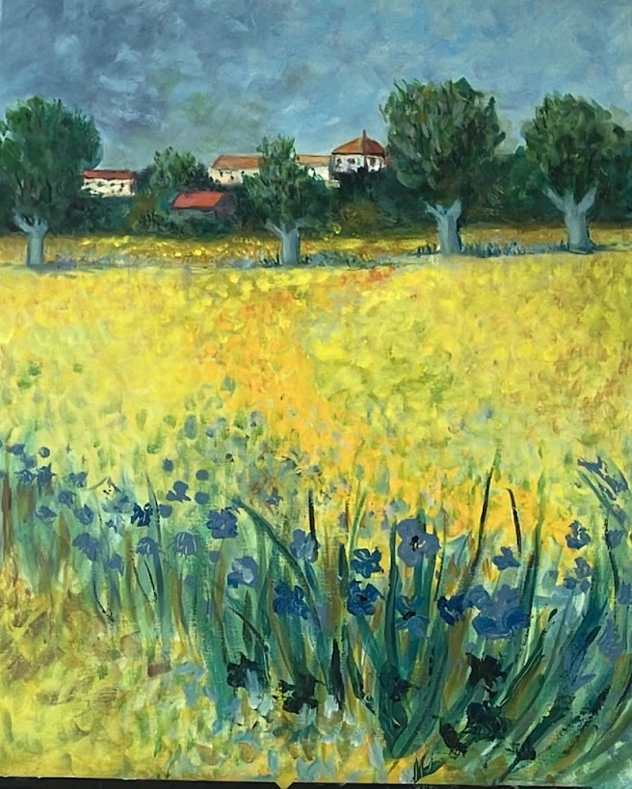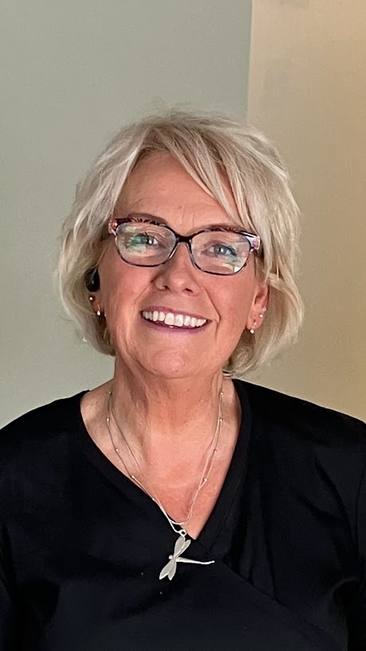
Kerstin Maxwell

Hello! I have worked for Golden Hills Lodge for over a year. I started February 22, 2022. I work in housekeeping, kitchen, dining room, and step-in Hairdresser. I am married with two adult children in their thirties and two Grandchildren who live in Lethbridge, Alberta. I love to paint, play music, photography, and entertain guests. I am a very creative person and love to create. If you see me around, please say hello!

Staff Spotlight

Name That Resident

Can you guess who this resident is using their clues? The answer will be revealed at our monthly Birthday Tea!
- I have a degree in religious education.
- I like fresh fruit.
- I spent one Christmas in the Hospital
- I like Hobbies.

WHO AM I??
I will be revealed at our April Birthday Tea!

